**WEEK 4**

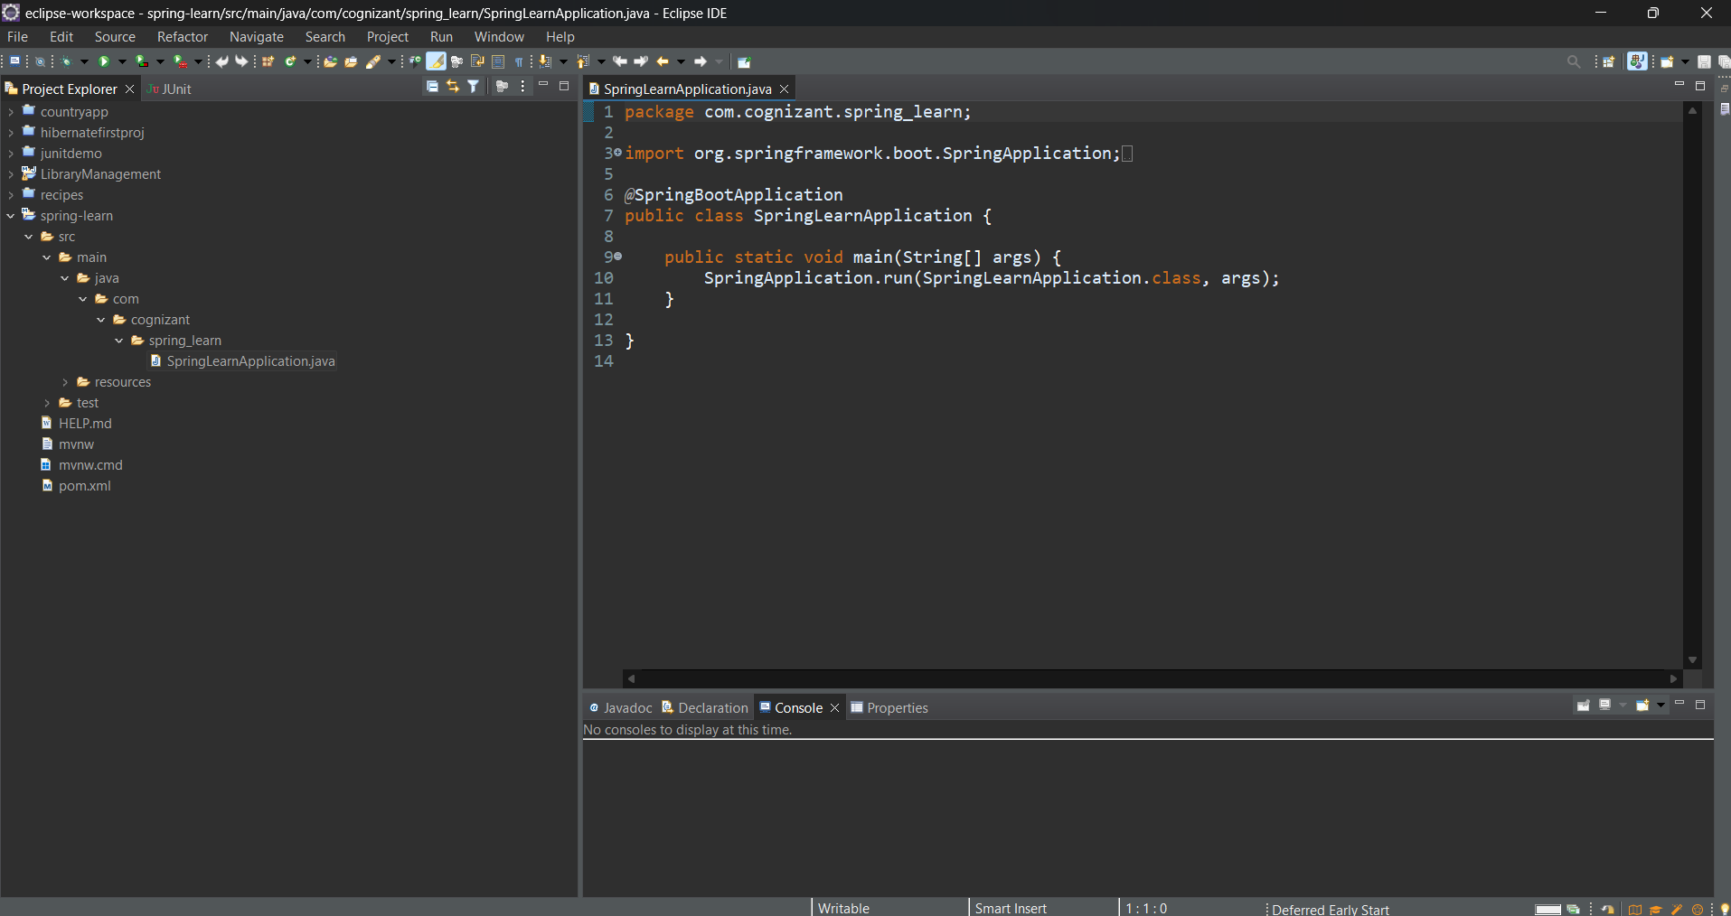

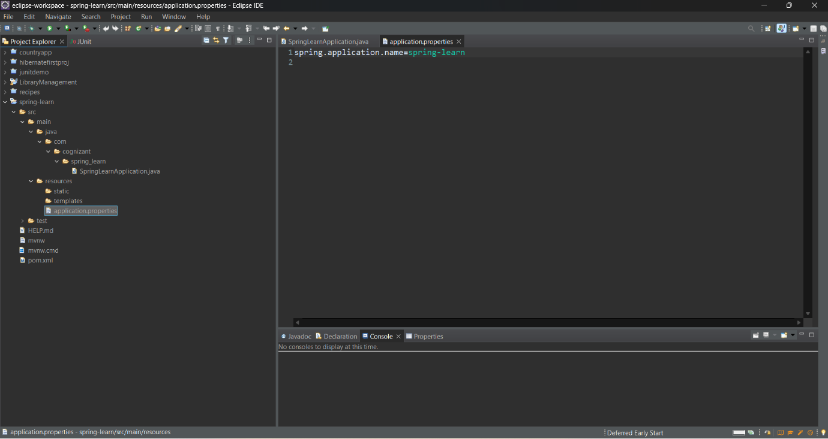

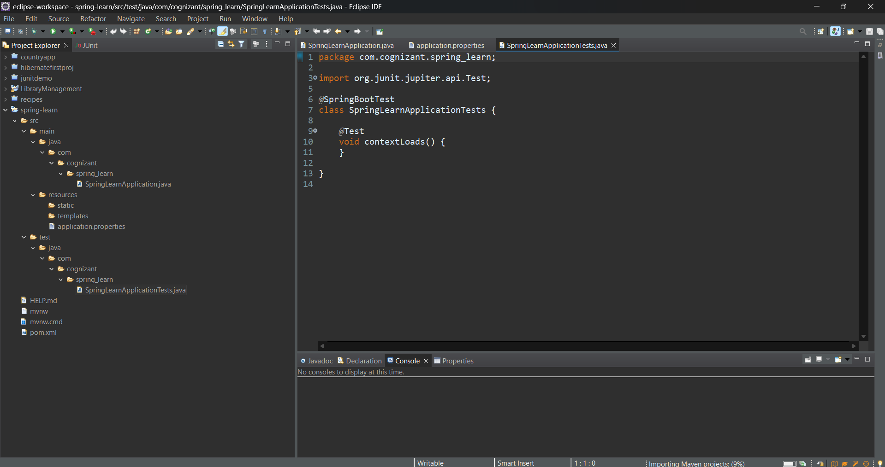

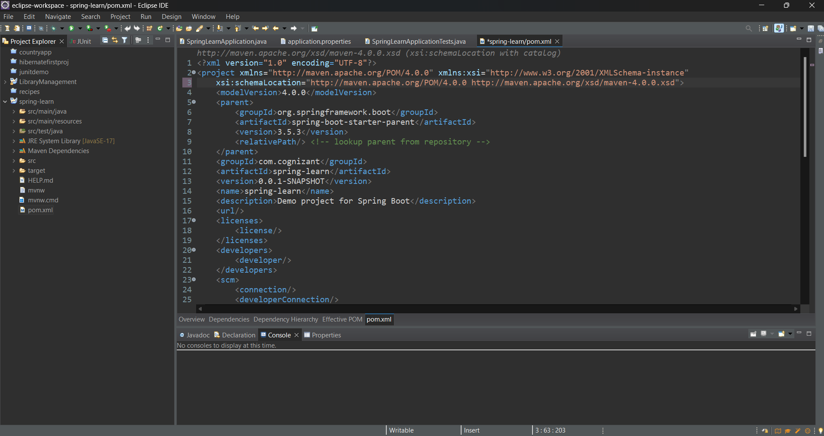

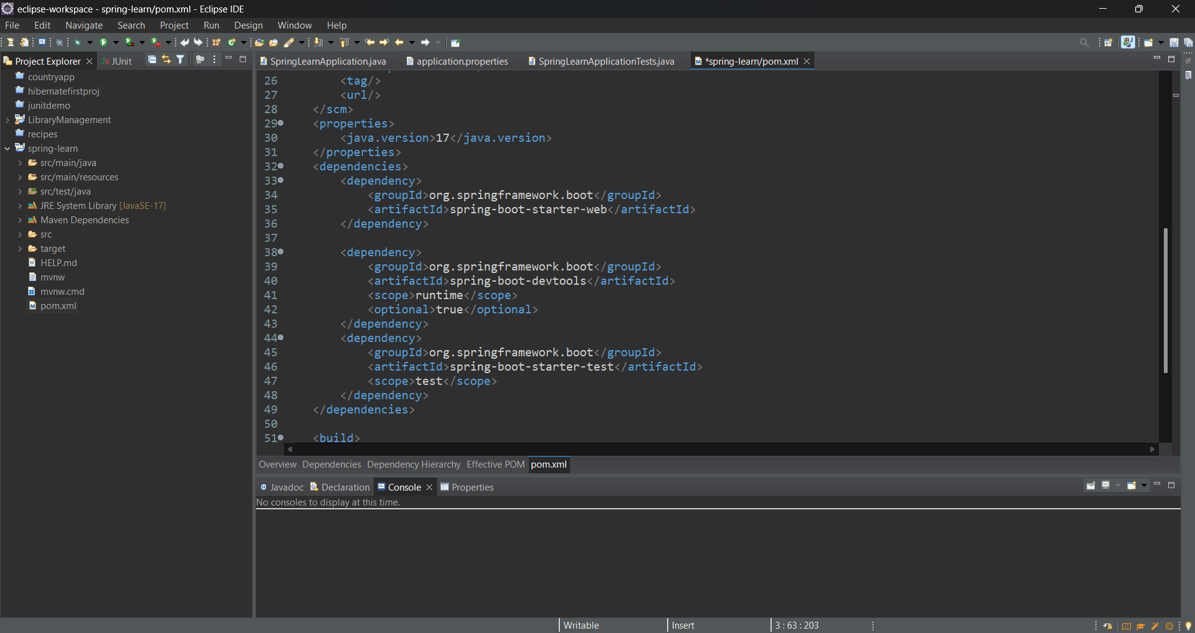

**date-format.xml**

<?xml version="1.0" encoding="UTF-8"?>

<beans xmlns="http://www.springframework.org/schema/beans"

xmlns:xsi="http://www.w3.org/2001/XMLSchema-instance"

xsi:schemaLocation="http://www.springframework.org/schema/beans

https://www.springframework.org/schema/beans/spring-beans.xsd">

<bean id="dateFormat" class="java.text.SimpleDateFormat">

<constructor-arg value="dd/MM/yyyy" />

</bean>

</beans>

**SpringLearnApplication.java**

package com.cognizant.spring_learn;

import java.text.ParseException;

import java.text.SimpleDateFormat;

import java.util.Date;

import org.slf4j.Logger;

import org.slf4j.LoggerFactory;

import org.springframework.boot.SpringApplication;

import org.springframework.boot.autoconfigure.SpringBootApplication;

import org.springframework.context.ApplicationContext;

import org.springframework.context.support.ClassPathXmlApplicationContext;

@SpringBootApplication

public class SpringLearnApplication {

private static final Logger LOGGER = LoggerFactory.getLogger(SpringLearnApplication.class);

public static void main(String[] args) {

SpringApplication.run(SpringLearnApplication.class, args);

SpringLearnApplication app = new SpringLearnApplication();

app.displayDate(); // Call the method to test date parsing

}

public void displayDate() {

LOGGER.info("START");

ApplicationContext context = new ClassPathXmlApplicationContext("date-format.xml");

SimpleDateFormat format = context.getBean("dateFormat", SimpleDateFormat.class);

try {

Date date = format.parse("31/12/2018");

LOGGER.debug("Parsed Date: {}", date);

} catch (ParseException e) {

LOGGER.error("Date parsing failed", e);

}

LOGGER.info("END");

}

}

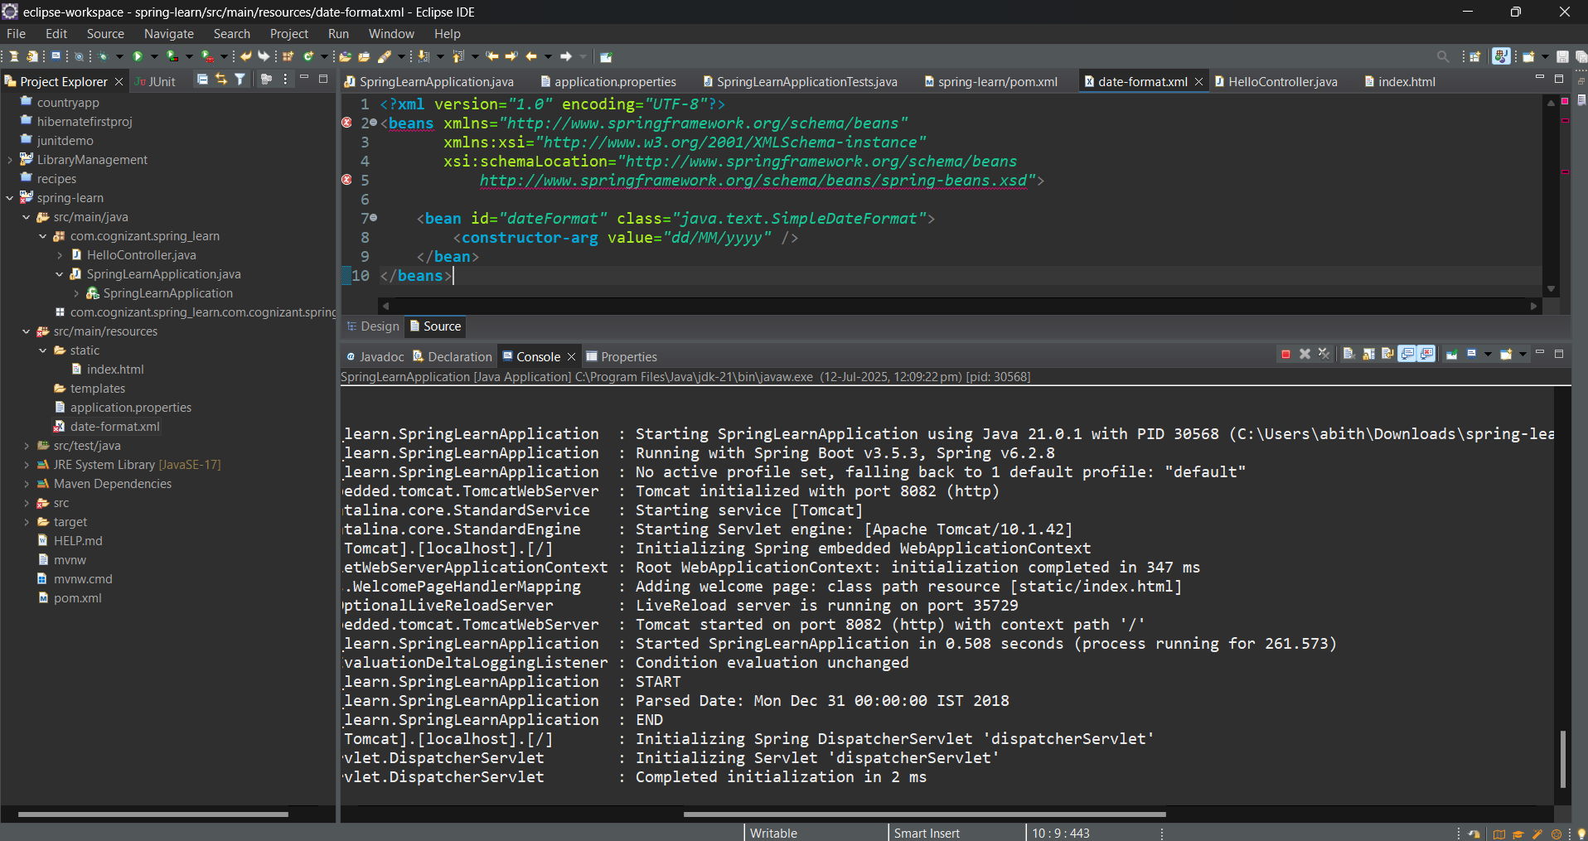

**application.properties:**

logging.level.org.springframework=info

logging.level.com.cognizant.springlearn=debug

logging.pattern.console=%d{yyMMdd}|%d{HH:mm:ss.SSS}|%-20.20thread|%5p|%-25.25logger{25}|%25M|%m%n

**date-format.xml:**

<beans xmlns="http://www.springframework.org/schema/beans"

xmlns:xsi="http://www.w3.org/2001/XMLSchema-instance"

xsi:schemaLocation="http://www.springframework.org/schema/beans

https://www.springframework.org/schema/beans/spring-beans.xsd">

<bean id="country" class="com.cognizant.springlearn.Country">

<property name="code" value="IN" />

<property name="name" value="India" />

</bean>

</beans>

**Country.java**

package com.cognizant.spring_learn;

import org.slf4j.Logger;

import org.slf4j.LoggerFactory;

public class Country {

private static final Logger LOGGER = LoggerFactory.getLogger(Country.class);

private String code;

private String name;

public Country() {

LOGGER.debug("Inside Country Constructor.");

}

public void setCode(String code) {

LOGGER.debug("Setting code: {}", code);

this.code = code;

}

public void setName(String name) {

LOGGER.debug("Setting name: {}", name);

this.name = name;

}

public String getCode() {

LOGGER.debug("Getting code");

return code;

}

public String getName() {

LOGGER.debug("Getting name");

return name;

}

@Override

public String toString() {

return "Country [code=" + code + ", name=" + name + "]";

}

}

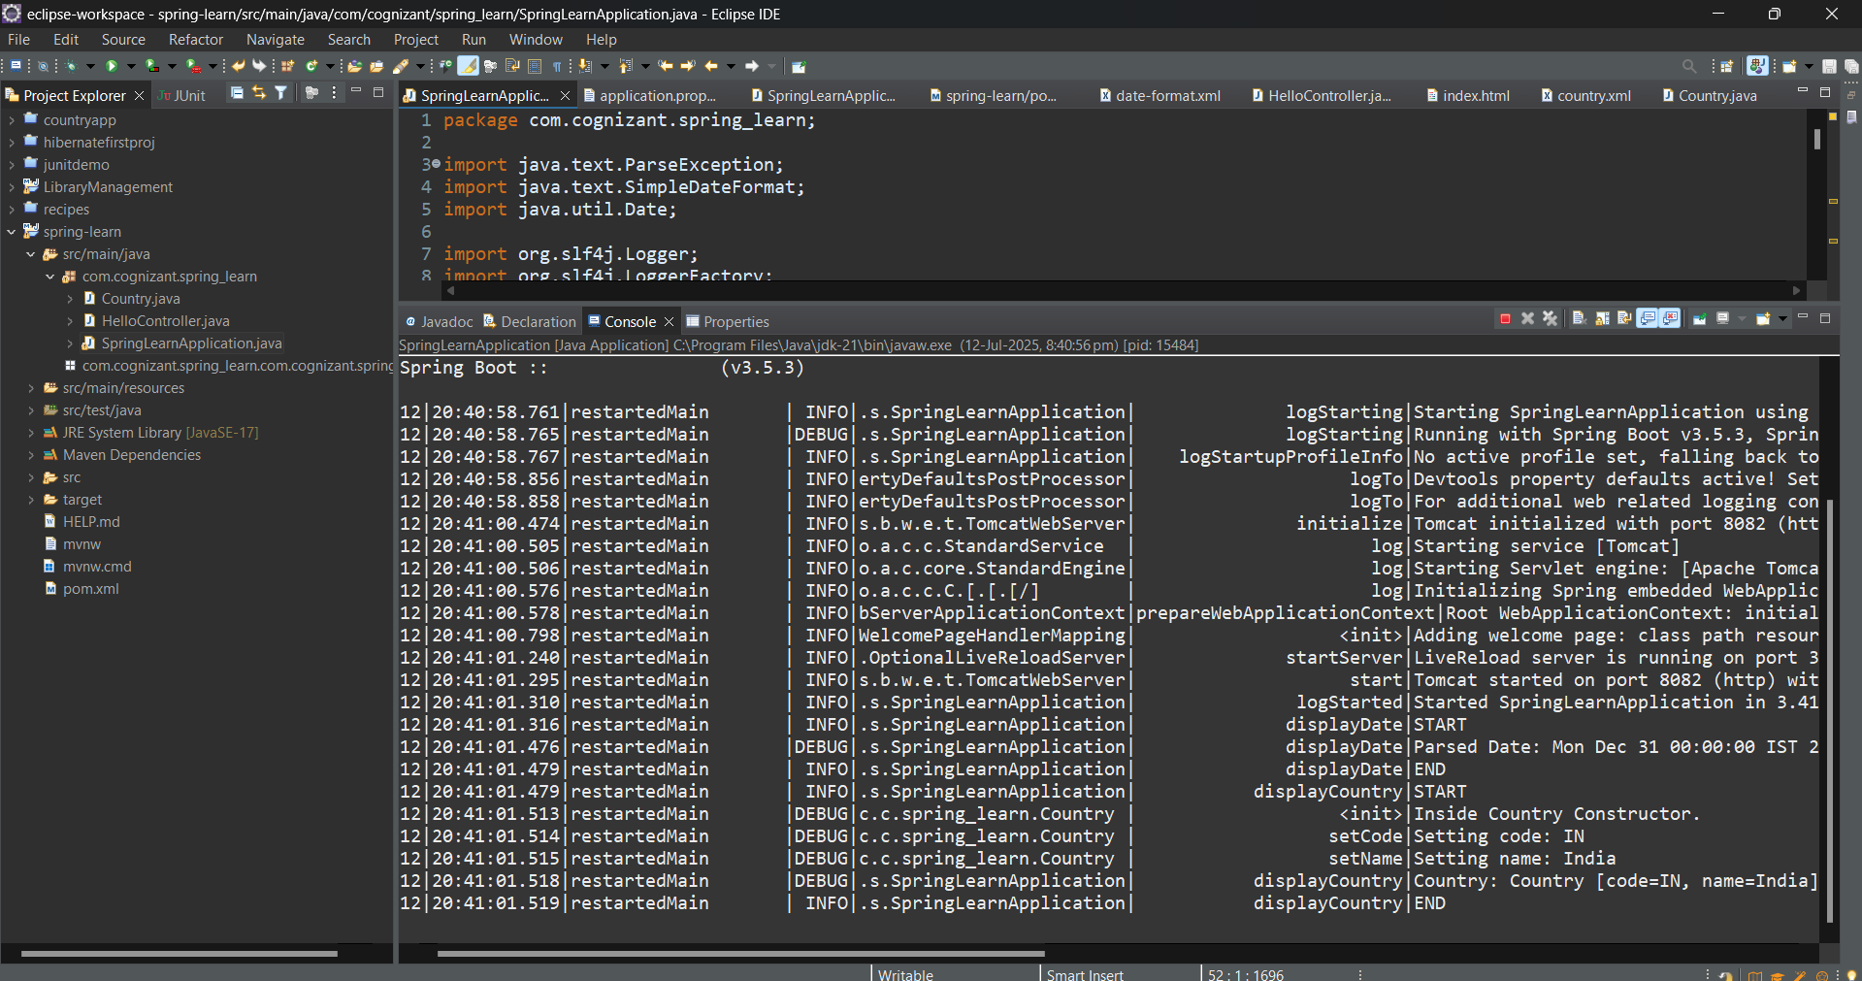

**Application.properties:**

# Set custom server port

server.port=8082

# Application name

spring.application.name=spring-learn

# Logging Levels

logging.level.org.springframework=INFO

logging.level.com.cognizant.spring_learn=DEBUG

# Console log pattern

logging.pattern.console=%d{yyMMdd}|%d{HH:mm:ss.SSS}|%-20.20thread|%5p|%-25.25logger**{25}**|%25M|%m%n

**country.xml**

<bean id="in" class="com.cognizant.springlearn.Country">

<property name="code" value="IN" />

<property name="name" value="India" />

</bean>

<bean id="us" class="com.cognizant.springlearn.Country">

<property name="code" value="US" />

<property name="name" value="United States" />

</bean>

<bean id="de" class="com.cognizant.springlearn.Country">

<property name="code" value="DE" />

<property name="name" value="Germany" />

</bean>

<bean id="jp" class="com.cognizant.springlearn.Country">

<property name="code" value="JP" />

<property name="name" value="Japan" />

</bean>

<bean id="countryList" class="java.util.ArrayList">

<constructor-arg>

<list>

<ref bean="in" />

<ref bean="us" />

<ref bean="de" />

<ref bean="jp" />

</list>

</constructor-arg>

</bean>

**SpringLearnApplication.java**

public void displayCountries() {

LOGGER.info("START");

ApplicationContext context = new ClassPathXmlApplicationContext("country.xml");

List<Country> countries = context.getBean("countryList", List.class);

for (Country country : countries) {

LOGGER.debug("Country: {}", country.toString());

}

LOGGER.info("END");

}